COMMUNAL THREATS & COMMUNITY RESILLIENCE:
THE POSTCOLONIAL PROMISE OF PANCHAYAT RAJ INSTITUTIONS

Maitreyee Singh

The Diasporic Gaze

The panchayat system of local governance and adjudication is often presented as a precolonial institution with potential for mediating postcolonial conflict. Examining the panchayat system more closely, however, complicates understandings of both communal conflict and networks of community in India. I strive to be cleareyed in my concept of India, and yet I’ve been surprised in the writing of this paper by my overidealized perception of this uniquely Indian institution. There are, of course, no fixed or essential qualities ascribable to the individuals who participate in panchayat structures by simple shared virtue of living in a village. Still, in my limited and purely anecdotal experience, I found such bodies to be spaces where minds were meaningfully changed and where connections were reified. Neighbors sat side-by-side did not indulge abstractions of Hindutva alarmism, engrossed as they were in matters of material importance to their lives. Such conditions provided me with hope I have continued to draw from. I must acknowledge, however, that my limited exposure to the internal politics of each village, uneven self-selection regarding what bodies were welcoming outside observers, and my lived and presented identity as an Americanized, educated, upper-caste young woman all informed my perception of these encounters.
I seek, therefore, to gain objectivity on the conditions of both conflict and potentiality in India in pursuit of a different source of hope: a clarity that might breed purpose. To that end, I trace here the gnarled and interwoven roots of communal violence and of local governance institutions as they have each traversed through and beyond colonialism. In engagement with analytical frameworks grounded by Homi Bhabha’s concepts of mimicry, hybridity, and the pedagogical object, as well as and Partha Chatterjee’s positioning of inner and outer domains, derivativity, and civic versus political society, I hope to come to a more historically and theoretically grounded understanding of the role that PRIs (Panchayat Raj Institutions) and similar Alternative Dispute Resolution mechanisms might or might not be equipped to play in redressing communal conflict in contemporary India.
This work is motivated in part by an appreciation for the importance of decentering Western epistemologies and desire to engage more deeply with local histories. It’s well established that colonialism created a global system of power relations that privileges Western ways of knowing over those of non-Western cultures resulting in the erasure and marginalization of non-Western cultural practices, such as forms of community-based justice like the panchayat. I believe engaging more deliberatively with such forms of knowledge and cultural practices might guide an understanding of their future potentiality. Thus, this work intends to interrogate the Indian state’s imagination of law, space, and self, amidst increasingly contradictory and contested landscapes, motivated by the imperative to understand and document the complex dynamics shaping conflict and a lack of effectual conflict resolution mechanisms.

Communalizing Colonial Policies
“The legacy of nurtured local hatreds can be seen wherever the Union Jack flew" (Carroll 2001: 82).
While British employment of a divide-and-rule strategy is soundly established, its reverberations are challenging to measure. Here, empirical modeling provides surer footing. Through a cross-national time-series analysis of 114 countries over 40 years, Lange, et al. found that specific forms of colonialism correlated directly with the increased risk and intensity of specific forms of post-independence civil violence (2009: 2). Their models showed that variables gauging different markers of coloniality strongly and consistently corresponded to levels of communal conflict between 1960-1999 within those former colonies, empirically substantiating claims that communal violence is a common legacy of colonialism. Further, they found the British to have been the colonizing power most strongly correlated to communal violence in particular, with levels of inter-communal conflict that were 1.4 points higher than non-colonies on average. In analyzing their findings, they clustered policies and impacts to assert that there were four main approaches to “communalizing colonial policy” (CCP): oppositional communal identities; communal divisions of labor; ethnic-based stratification; animosity between indigenous and non-indigenous populations; or some combination of the four (Lange 2021:11).
Their work suggests that not only is former colonial status an important predictor of levels of post-colonial communal conflict, per conventional belief, but also that different types of communalizing colonial policy (CCP) inhere in specific, often predictable postcolonial patterns of ethnic warfare. Thus, relatively non-discriminatory CCPs, defined to include, for example, the use of communal census categories and high levels of indirect rule, had limited or mixed effects on postcolonial ethnic conflict, whereas unequal communal representation in government, police forces, or armed forces in conjunction with indirect indigenous rule, all classified by the researchers as discriminatory CCPs, were shown to significantly increase the odds of postcolonial ethnic warfare (Lange, 2009: 9). As the researchers note, the British employed each of these policies in South Asia.
Beyond these findings, a broad body of research on the correlates of ethnic tension demonstrate the ways in which factors like ethnic polarization, interethnic income inequality, and ethnic violence are associated with such outcomes as slower economic growth, weaker state capacity, heightened political rebellion indices, and the under provision of public goods. This is important framing from which to appreciate the contours of the issue of communal and ethnic violence in modern India. While the British colonial state did not invent religious or caste-based division, it is entirely reasonable to believe that their ideological and administrative influences on colonial India continue to guide “the twists and turns, the suppressed possibilities, and the contradictions still unresolved” of modern India (Chatterjee, 1989: 22). Accordingly, this context must undergird any understanding of or hope for meaningful conflict resolution.

Precolonial Panchayati Systems

To better appreciate the ways in which the colonial state has configured the present, it is useful to first understand some conditions of the precolonial site upon which they acted. Villages served as core social and economic units of 19th century South Asian society, operating with a degree of self-rule through such institutions as the panchayat (Metcalf, 1995: 450). Describing villages around Delhi in the years after the collapse of Mughal power, Governor-General Metcalfe wrote to the East India Company’s charter:
The village communities are little republics, having nearly everything they can want within themselves and almost independent of any foreign relations... Dynasty after dynasty tumbles down; revolution succeeds to revolution; Hindoo, Pathan, Mogul, Mahratta, Sikh, English, are all masters in turn; but the village community remains the same...This union of the village communities, each one forming a separate state in itself, has, I conceive, contributed more than any other cause to the preservation of the people of India through all the revolutions and changes which they have suffered, and is in a high degree conducive to their happiness, and to the enjoyment of a great portion of freedom and independence (Cohn, 1987: 213).
British observers reported these panchayats to be fundamental judicial institutions derived from India's “ancient constitution and common law… [that could] administer justice according to the customs of the country" (Jaffe, 2014: 143). Accounts by the British are numerous and lengthy in their appraisals, and although the objective reality of the accounts cannot be known, they offer valuable insights into the evolving colonial ethos. One British officer remarked on the system, that civil justice in India “seems not to differ much – from what we understand – to be our own antient [sic] local Courts” (qtd. Jaffe, 2015: 4). Others noted the difference as more pronounced: "Arbitration was indeed a conspicuous element of ordinary Indian life, and it occurred in all levels of life to a considerably higher extent than was the case in the case of the Europeans, referring a problem to a Panch was a natural manner of resolving many issues in India" (qtd. Tewari, 2005: 3).
According to Yogendra Singh the basic components of the social system in precolonial India were relatively autonomous, and this system prohibited kings or administrators from intervening in disputes related to local customs, norms, or the practices of castes or tribes, which had their own dispute resolution processes through panchayats (2004). These community leadership forces comprised of respected elders, and the main features of this legal system and its “judicial processes” are said to have been wider participation, compromise, flexibility and innovativeness (Singh, 2004). In rural communities, therefore, justice was imparted through “adjustment’ rather than ‘judgement” in an informal and inexpensive process and in accordance with the cultural ethos of the community and moral values (Singh, 2004).
Administrative use, then, of the panchayat as "the great instrument in the administration of justice" by the British between 1819 and 1827 entailed adapting it to the needs of colonial officials as an inexpensive, accessible, and efficient judicial institution (Jaffe, 2015: 22). However, the British system of hierarchical administration emphasized centralized control and formal legal structures, so they incorporated panchayats into their administration through a spate of legislation and politicking: Mayo’s Resolution of 1870 on financial decentralization, Lord Ripon’s policy of local self-government in 1882, attempts by Chief Secretary William Wedderburn to revive the village Panchayat in Bombay in 1887, the 1908 report of the Royal Commission on decentralization, and the Montague-Chelmsford Report (1918) were significant moments in this trend of formally vesting village Panchayats with legal powers.
Although the village committees had successes (Bengal panchayats disposed 122,760 cases in 1925, for example), they soon lost their importance, partly due to their subversion by the British court system (Tinker, 1954). In practice, colonial absorption of the system required regularizing of procedure, supervising of operation, limiting of jurisdiction, and, in general, molding the panchayat into a structure of British judicial administrative bureaucracy with constant adjustment and repeated intervention. One such reengineering was the repeated expansion of the number of commissioners and magistrates employed to monitor and supplement the panchayat, effectively recentralizing an intrinsically decentralized system (Jaffrelot, 2005: 12). As a result, by the late 19th century, the panchayat was transformed into a new institution, warped and undermined by the colonial encounter. It retained only its name, a mere semblance of its former self.

Divide et Impera

The 1857 Mutiny greatly affected the political calculus of British rule in India. In the aftermath, the British Government initiated investigations into the Indian Army's organization, beginning with the Peel Commission's appointment in 1859 (Stewart, 1951: 49). The Commission, aiming to identify the Bengal Army's weaknesses that led to the Mutiny, heard from numerous witnesses that the principal problem with the mutinied Army was that individuals from various races, classes, and clans were mixed up in the ranks, which destroyed their racial prejudices and inspired them with a common sentiment.
Sir John Lawrence remarked on the care that should be taken "to preserve that distinctiveness which is so valuable, and while it lasts, makes the Mahomedan of one country despise, fear or dislike the Mahomedan of another… By the system thus indicated, two great evils are avoided: firstly, that community of feeling throughout the native army and that mischievous political activity and intrigue which results from association with other races and travel in other Indian provinces" (qtd. Ambedkar 1946: 92). The attendant policy was known as “the principle of Class Composition,” officially recommended by the Peel Commission as a principle of Indian Army Policy (Ambedkar, 1946: 93). Lord Elphinstone, Governor of Bombay, also noted for the Commission: “… I am convinced that the exact converse of this policy of assimilation is our only safe military policy in India. ‘Divide et impera’ was the old Roman motto and it should be ours.” (Stewart, 1951: 52) Sir John Stachey put it even more bluntly, stating that "the existence side by side of the hostile creeds is one of the strongest points in our political position" (Tharoor, 2017).
In 1906, then-Viceroy and Governor-General Lord Minto invited Indian Muslim elites and landlords to Shimla; shortly thereafter, the Aga Khan III convened a deputation of Muslim leaders to discuss the British offer of safeguarding the Muslim community's interests. At this, the first meeting of the Muslim League, resolutions expressed "loyalty to the British government" and support for Bengal partition (Siddiqui, 2017: 9). Lady Minto would later update the British Foreign Secretary that, "our policy of dividing the Indian community on religious and caste basis will prolong and strengthen our rule in India" (Siddiqui, 2017: 9).
Such statements illustrate there was no need for obfuscation by colonial officials: the post-1857 rule of India was marked by avowed fractionalization, polarization, and segregation. The colonial state, with its immense power, codified and fomented division in a bid to inhibit nationalism. The line connecting British divide-and-rule policies and the communalism apparent in modem India is undeniable. It is also true, however, that the colonial state could succeed in this endeavor only because of the internal social and political conditions of the colonized state.

Negotiating Colonial Subjection through Mimicry

Homi Bhabha argues that British colonial administration incited “mimetic desire” in its colonized subjects, described as the imitation or adoption of dominant cultural forms by the colonized subjects (1994b). Ultimately, this desire is doomed to failure, as mimicry is predicated on repetition with difference: “almost the same, but not quite” (Bhabha, 1994b: 127). However within this difference, he argues, colonial subjects produce “parodic understandings of colonial civility,” thereby exposing it to critique (1994b: 168).
The Ilbert Bill controversy of 1884 and the role of Indian barrister and civil servant Behari Lal Gupta, illustrate this dynamic. Having inspired the Bill advocating for Indian judges to have the same powers as British judges, Gupta’s mastery of British legal values and principles contested entirely passively with colonial control. Gupta challenged the colonial power structures that denied Indians equal legal rights simply by wielding knowledge of British law. Bhabha’s mimicry here becomes a tool for negotiation and resistance, allowing colonized individuals to traverse within the colonial legal framework while simultaneously critiquing and destabilizing colonial hegemony. This in turn destabilizes power relations, complicating and transforming both colonizing British and colonized Indian identities. Such mimicry laid bare the hypocrisy and insincerity undergirding the colonial regime, revealing the tension in ostensibly universalist Enlightenment values when confronted with the “rule of colonial difference” justifying British occupation (Chatterjee, 1993:19).
Mimetic practice shapes, too, the colonized national consciousness. Partha Chatterjee notes how anti-colonial Indian nationalism itself employed colonial thought and models in its articulation (1993). He explains:
Nationalism… seeks to represent itself in the image of the Enlightenment. [But,] for Enlightenment itself, to assert its sovereignty as the universal ideal, needs its Other; if it could ever actualize itself in the real world as the truly universal, it would in fact destroy itself (Chatterjee, 1986: 17).
Thus, relationally oppositional power structures necessitate that the dominated have their own domain of subjectivity, where they were undominated. The nationalist response was to constitute a new sphere of the private domain marked by cultural difference and particularity from other communities. This insight, in conjunction with Bhabha’s framing of the nationalist project, highlight how nationalist narratives both constructed and educated colonized peoples as “pedagogical objects,” often through arbitrary historical inventions. Afterall, “nationalism is not what it seems, and above all not what it seems to itself” (Bhabha, 1994a: 142).

The “Derivative Discourse” of a Nascent Nationalism

Alongside Bhabha’s model of colonial mimicry, Partha Chatterjee’s notion of colonial nationalism as a “derivative discourse” is a valuable theoretical framework from which to further observe the nexus of coloniality, communality, and community (1986). In particular, the project of national identity construction can be compellingly filtered through this schema.
Chatterjee contends that British colonial discourse shaped and constructed new identities in India. The British deployed a language of religion that was not only different from the one that Indians had used in the past, but also demarcated a new kind of identity (the 'Mohammadan' or the 'Hindoo') (1993: 95-115). The British astutely fomented cleavages in manufacturing pedagogical subjects: "Not only were ideas of community reified, but also entire new communities were created by people who had not consciously thought of themselves as particularly different from others around them." (Tharoor, 2017). Of course, there were historical antagonisms between Muslims and Hindu peoples prior to colonization. To indulge in a romanticized view of a harmonious precolonial India would serve no intellectually honest purpose. Yet this does not diminish from a mimetic othering of Muslim populations in Indian nationalistic imaginations that Chatterjee alleges: leaning on tropes of the Muslim complementary with western Orientalist renderings (as “fanatical, bigoted, warlike, dissolute, and cruel”) in mimetic practice, informed by dominant colonial powers and rearticulated by a colonized subject (1993: 108).
Further, Chatterjee argues that the religious nationalism that continues to serve as pretext for violence in India is not in contradiction to the imagining of India as a nation, but implicit in it. Through 19th-century Bengali history textbooks, Chatterjee shows that the constructed past of India was a Hindu past and the constructed Indian, a Hindu (1992). The British also imposed a narrow and exclusive understanding of citizenship. He even speculates on the colonial utility of this undertaking:
"The idea that 'Indian nationalism' is synonymous with 'Hindu nationalism' is not the vestige of some premodern religious conception. It is an entirely modern, rationalist, and historicist idea. Like other modern ideologies, it allows for a central role of the state in the modernization of society and strongly defends the state's unity and sovereignty. Its appeal is not religious but political. In this sense the framework of its reasoning is entirely secular" (Chatterjee, 1992: 147).
These colonial legacies persist in shaping Indian politics and society today, contributing to ongoing communal tensions and violence. Thus, the “derivative discourse” of Indian nationalism is testament to the tenacious afterlife of colonial processes of subjectification.

“Post-colonial” Panchayati Systems
Coloniality, then, is an ongoing process that continues to shape the social, political, and cultural dynamics of postcolonial societies. As such, understanding the precolonial past is crucial for understanding the present and envisioning alternative futures. Historical legacies and power dynamics have both fundamentally altered, for example, the ways in which conflict resolution processes function in contemporary society, and also colored the ways we understand their precolonial conditions. And as an elite echelon of powerbrokers decided newly independent India’s fate from New Delhi, these narratives were important touchstones. Though Gandhi was famously and vocally supportive of Panchayati Raj Institutions, it was deemed untenable for the young State favoring a highly Centralized government.
By 1957, the government established the Balwantrai Mehta Committee, which recommended a three-tier Panchayati Raj system at the village, block, and district levels (Baxi, 1982). Following the Mehta Committee Report in 1959 and this reorganization of village institutions, several states established panchayats as separate judicial bodies (Baxi, 1982). By 1977, however, after little traction in this arena, the Ashok Mehta Committee on Panchayati Raj reported its finding that inadequate resources were responsible for the failure of PRIs and again recommended reviving and strengthening PRIs. As a result of this report, Karnataka, Andhra Pradesh, and West Bengal passed new legislation (Baxi,1982: 307). Finally in 1992, the Parliament codified the policy, passing the Seventy-third Amendment Act to the Constitution. It was a landmark in the history of local self-government in the country and gave constitutional mandate to state governments to restructure and restore local bodies as institutions of self-government. The Panchayati Raj System and its offshoot the Lok Adalat quickly became the cheapest path to justice for the weaker sections of the society.
The various commissions claimed that the system would ensure public participation in the administration of justice, and that it would encourage confidence and help to lighten litigants’ apprehensions regarding the judicial system because of the “informal atmosphere, conciliatory approach, use of local language, and lack of procedural and evidentiary technicalities” (Galanter and Meschievitz, 1982). Since adjudication would be based on local custom and tradition, many of the defects and inadequacies of the ill-suited British legal system would ostensibly be eradicated, and guided by local traditions, the village community could infuse confidence in the people towards the administration of justice (Baxi, 1982: 327).
Per Foucault, power is the enveloping of juridical sovereign power by technologies of government. When justice might be based on caste, community, personal or political considerations, then, idyllic notions of community justice are marred by power hierarchies that are neither natural, incidental, nor accidental. Colonial structures of power wherein native elites were co-opted into colonial administration, vestiges of pseudo-scientific race/caste typology, and reductive and bastardized understandings of social structures among other residuals of colonialism linger in contemporary society (Chatterjee, 1993). Thus, respected and ostensibly neutral village elders imagined to be leading these institutions were long ago replaced in positions of power by leaders based on caste, money, or political affiliations. Indeed, modern Indian panchayats have occasionally been sites of heinous punishments and targeted violence, like the 2013 Muzaffarnagar Riots.

An Imagined Past, a Hybridized Future

Here, Bhabha’s dialectics of mimicry and hybridity allow for a more critical reading of postcolonial panchayats in India in dialogue with colonial structures and legacies. PRI institutions imperfectly mimic both Western legal structures and historically inconsistent Indian traditions, such that its worth questioning to what extent (and to what end) India might be mimicking an imagined self. Bhabha's work on the role of mimicry also provides a useful lens for understanding the ways in which the panchayat system has been transformed and adapted over time. As a precolonial form of local governance that has persisted into the present day, the panchayat system can be seen as a form of mimicry that has been adapted to fit the demands of contemporary Indian society.
Modern panchayats and PRIs are hybrid institutions born out of encounters between colonial and indigenous traditions. As described by Bhabha, hybridity is the result of cultural identity forming within the context of colonial antagonism. In this process, the colonial authority seeks to fit the identity of the colonized Other into a singular, universal framework but inevitably fails. This failure gives rise to something both familiar and novel—a new hybrid identity (Bhabha 1994a: 25). This identity emerges from the blending of elements from both the colonizer and the colonized, replacing the established patterns with a simultaneously “mutual and mutable representation of cultural difference” that is positioned “inbetween” the colonizer and colonized. (Graves, 1998). In this way Bhabha highlights the primacy of interactions and collisions in shaping cultures and identities:
It is significant that the productive capacities of this Third Space have a colonial or postcolonial provenance. For a willingness to descend into that alien territory . . . may open the way to conceptualizing an international culture, based not on the exoticism of multiculturalism or the diversity of cultures,but on the inscription and articulation of culture’s hybridity” (Bhabha 1994a: 38).

Promise of Community

Likewise, Partha Chatterjee's framing of postcolonial derivativity suggests that the failure of the nation to fully establish itself stems from being caught in between inadequate originality and inadequate imitation (1986, 61). This view highlights how nations struggle to find their unique identity, often oscillating between not being distinct enough from established norms and not being innovative enough to break away from imitation.
If as Foucault claims, modern power is marked by juridical control, Chatterjee contends that such governmentality does not entirely envelop juridical sovereignty and it is at these contested sites that the rights of minority communities might be won (2004: 11). At these points, he argues, liberal forms of government reach their limits because individual communities are able to assert a right not to offer reasons for their difference. Preempting criticism that this would be a concession to cultural relativism, Chatterjee argues this can be overcome through internal democracy and mechanisms of accountability within communities with the most motivation for protecting their homes.
Chatterjee argues the Indian “civil society” of English-educated middle-class elites who have dominated social, literary, and political life and who played an important part in the anti-colonial struggle (1998: 42), can no longer determine the the politicization of rights and the social struggles; those at the social peripheries have made the public spheres of civil society into arenas of political democracy (2004). They can press their claims in the political terrain, not as passive subjects, but as citizens through political structures like the panchayat raj, what Chatterjee calls “political society.” The legitimacy of the modern state and democracy in India, then, would no longer be dependent on either the hegemony of the elites or on acts of charity granted from above, but rather, grounded on the idea of popular sovereignty: “the politics of the governed” (2004).
Noting the challenge of Hindutva politics in India, like Bhabha, he emphasizes the need to engage with the distinct Indian modernity shaped by European ideas, rather than seeking solutions through platitudes of a traditional Indian religious toleration. Celebrating aspects of everyday tolerance in the hope that the state might learn something is an anemic and untenable approach to combatting structurally embedded injustices: feel-good stories will not be a panacea. Rather, the problems of contesting modern religious identities must be negotiated through modern state institutions which provide the necessary backdrops to rework normative liberal accounts to suit modern Indian concerns. There are political possibilities within these domains when understood in terms of their hybridity, and as such, this modernity is the only ground on which schemes of progress can be built, “[by] applying the right pressure at the right places in the governmental machinery… mobilizing population groups to produce a local political consensus” (Chatterjee, 2004: 66).
He emphasizes that in these domains of political society, when, for example, community leaders gain the trust of community to plead their case and secure the confidence of the administrators to find a consensus that will stick, they do not just embody the trust generated among equal members of a civic community, but they also mediate between domains differentiated by historically entrenched power inequalities. Successful mobilizations of political society to affect the implementation of governmental activities in their favor, then, are expansions of the freedoms of people that would not have been possible strictly by using means of civil society. Countering forces of governmentality is only possible, then, by investing their empirical collective identity with the moral attributes of the community. Paralegal apparatuses like Panchayati systems, then, in spite of their ambiguous and supplementary status in relation to the legal the activities of governmental functions, produce classes of varied populations that come together in political action. The institutionalization of PRIs since the 1990s has helped to break the isolation of villages by inroads of political media and governmental technology. In this way, panchayat systems weave the village into wider social fabrics, and with increasing democratization and intervention in civil society institutions, community justice becomes more possible.
As has been noted, however, the panchayat system has severe limitations and can be dangerously employed to amplify communal tensions, particularly in cases where conflicts are rooted in deep-seated social, economic, and political inequalities. There is significant potential for these systems to be co-opted by dominant groups and/or the state, thereby reinforcing existing power structures, often ossified by the colonial encounter. Patriarchal and casteist underpinnings in society can perpetuate inequality and exclusion through these bodies. Moreover, the system can be and historically has been co-opted by the state to maintain control over rural communities, undermining its potential as a tool for grassroots empowerment.
Ultimately, however, the utility and efficacy of the panchayat model of justice will depend on a range of factors including the degree of community involvement and participation in the decision-making process. By encouraging participatory decision-making and community-based conflict resolution, the panchayat system has the potential to facilitate a sense of community ownership and promote social cohesion, and serve as a counterforce to centralized power structures that exacerbate communal tensions as with the state-sponsored Hindutva ethos of post-2015 India. In my personally limited and anecdotal experience, I found these to be bodies of civic-minded and community-driven men and women electing to trust and care for one another in both symbolic and material ways. The trust between members of such bodies can allow for profoundly effective and affective collectivization.
It's important not to succumb to simplistic binary reductions of such arenas as formal/informal or colonial/post-colonial; rather, we must seek to better understand the ways in which these labels coalesce to hope to understand how they might be worked with and worked around. A subaltern and postcolonial approach to panchayat systems for resolving communal conflicts in India, then, must recognize the historical and structural power imbalances that underlie these conflicts and these conflict resolving bodies. Acknowledging the agency and promoting the participation of marginalized communities in resolution processes by prioritizing initiatives that are grounded in the lived experiences of those affected by conflicts.
Incredibly, in the aftermath of the 2013 Muzaffarnagar Riots, in which Hindu Jat Panchayats inflamed and catalyzed horrific violence and dispossession against local Muslims, it is these same town panchayats that efforts at reconciliation have occurred. “To help restore communal harmony in Lisaad village of Muzaffarnagar district, scores of residents have come forward to organise a joint Hindu-Muslim panchayat to resolve issues and extend support to each other… Sources said the main purpose of the panchayat was to restore confidence of villagers of both communities and to formulate a strong policy for better relationship between members of these communities and communal harmony” (Sharma, 2014). “A committee of 20 members, comprising social leaders and riot victims, has been constituted to contact the families of victims as well as the accused in nine riot-hit villages of Muzaffarnagar and Shamli districts… ‘Peace and harmony is possible only through dialogue’” (Raju, 2018).
As the Balwantrai Mehta Committee concluded in its 1957 Report: “Community development can be real only when the community understands its problems, realises its responsibilities, exercises necessary powers through its chosen representatives and maintains a constant and intelligent vigilance on local administration” (Mehta, 1978: 2-3).

Bibliography

Ambedkar, Bhimrao Ramji. (1946). “Weakening of the Defences” in Pakistan or the Partition
of India. India: Thacker. pp 78-101

Avruch, K., & Black, P. W. (1991). The Culture question and conflict resolution. Peace &
Change, 16(1), 22-45. https://doi.org/10.1111/j.1468-0130.1991.tb00563.x

Baxi, U. (1982). The Crisis of The Indian Legal System. Alternatives in Development Law.
India: Vikas Publishing House, Pvt. Ltd.

Bayly, CA. (2012) Recovering Liberties: Indian Thought in the Age of Liberalism and Empire
Cambridge: Cambridge University Press, p. 347.

Bhabha, Homi. (1996) “Unsatisfied: Notes on Vernacular Cosmopolitanism.” in Text and Nation: Cross-Disciplinary Essays on Cultural and National Identities. Ed. Laura Garcia-Moreno and Peter C. Pfeiffer. Columbia: Camden House.

B h(1994a) “DissemiNation: Time, Narrative, and The Subalternity of a Nationalist Elite Margins of the Modern Nation” in The Location of Culture, London: Routledge, 139–170

Bhabha, Homi (1994b) “Of Mimicry and Man: The Ambivalence of Colonial Discourse,” in The
Location of Culture (London: Routledge), pp 85-92.

Borooah, V.K., Tagat, A. and Mishra, V. (2020), "Conflict, caste and resolution: a quantitative
analysis for Indian villages", Indian Growth and Development Review, Vol. 13 No. 2, pp. 319-338. https://doi.org/10.1108/IGDR-08-2019-0087

Chatterjee, Partha, (1993) “The Colonial State,” in The Nation and its Fragments: Colonial and Postcolonial Histories, Princeton, Princeton UP, pp 14-34

Chatterjee, Partha. (1986) Nationalist Thought and the Colonial World: A Derivative
Discourse? London: Zed, 22.

Chatterjee, Partha (1989). “Colonialism, Nationalism and Colonialized Women: The Contest in
India,” American Ethnologist 16: pp 623–24.

(1992), "History and the Nationalization of Hinduism," in Social Research 59, No. 1, p. 111-147.

(2004). The Politics of the Governed: Reflections on Popular Politics in Most of the World (Leonard Hastings Schoff Lectures). United Kingdom: Columbia University Press.

Chaudhary, M. A. (1999). Justice in Practice: Legal Ethnography of a Pakistani Punjabi Village. New York: Oxford University Press.

Cohn, B. S. (1965). Anthropological Notes on Disputes and Law in India. American
Anthropologist, 67(6), 82-122. https://doi.org/10.1525/aa.1965.67.6.02a00960

Cohn, B(1987). Some notes on law and change in north India. In P. Bohannan (Ed.), Law
And warfare: Studies in the anthropology of conflict. New York: Natural History Press.

Denault, Leigh. (2018). Little Republics or Petty Republics? Comparative Studies of South Asia,
Africa and the Middle East, 38(3), 402–422. https://doi.org/10.1215/1089201X-7208757

Galanter M, Krishnan JK. (2003). Debased informalism: Lok Adalats and legal rights in modern
India. In Beyond… https://media.law.wisc.edu/s/c_8/ymy9n/mgdi.pdf

Galanter M, Meschievitz CS. (1982). “In search of Nyaya Panchayats: the politics of a moribund
institution.” https://api.law.wisc.edu/repository-pdf/uwlaw-library-repository-
omekav3/original/bcc574c4f38bc892c422e00f062f5e206416c1e9.pdf

Gohar, A. (2018). Returning to indigenous traditions of peacemaking, peacebuilding, and
peacekeeping: From Jirga (TDR) to restorative justice (ADR) in Pakistan. In T. Gavrielides (Ed.), Routledge international handbook of restorative justice (pp. 84-97). https://doi. org/10.4324/9781315613512
Graves, B. (1998). Homi K. Bhabha: an Overview. Retrieved from Postcolonial Web website: https://www.postcolonialweb.org/poldiscourse/bhabha/bhabha2.html

Jaffe, James A. (2014) “Custom, Identity, And the Jury in India, 1800–1832.” The Historical Journal 57, no. 1, pp 131–55. http://www.jstor.org/stable/24528913.

Jaffe Ja(2015). Ironies of Colonial Governance: Law, Custom and Justice in Colonial
India. Cambridge: Cambridge

Jaffrelot, Christophe. (2005) Dr. Ambedkar and Untouchability, Delhi: Permanent Black, p. 12

Jaiswal, Hrishikesh and Mandloi, Pragati, (2020). “Alternate Dispute Resolution in Rural India: A Brief Study About Panchayat System.” CB Eduvents-Legal Encyclopedia, https://ssrn.com/abstract=3817307

Kadir, Jawad (2019). “The Utility of Traditional Justice System of ‘Panchayat’ in Resolving
Pakistan-India Interstate Conflict.” https://icermediation.org/wp-content/uploads/2022/07/The-Utility-of-Traditional-Justice-System-of-Panchayat-in-Resolving-Pakistan-India-Interstate-Conflict-Jawad-Kadir.pdf

Lange, Matthew, Emre Amasyali, and Tay Jeong. (2021). "Communalizing Colonial Policies and
Postcolonial Ethnic Warfare: A Multimethod Analysis of the British Empire." European Journal of Sociology, 62 (2): 141-165.
Lange, Matthew and Andrew Dawson, (2009). Dividing and Ruling the World? A Statistical Test
of the Effects of Colonialism on Postcolonial Civil Violence, Social Forces, Volume 88, Issue 2, December 2009, Pages 785–817, https://doi.org/10.1353/sof.0.0255

Lederach, J. P. (1991). Of nets, nails, and problems: The folk language of conflict resolution in a
central american setting. In K. Avruch, P. W. Black, J. A. Scimecca (Eds.), Conflict resolution: Cross-cultural perspectives (pp. 165-86). Westport, CT: Greenwood Press.

Mannathukkaren, Nissim. (2010) “The ‘Poverty’ of Political Society: Partha Chatterjee and the People’s Plan Campaign in Kerala, India.” Third World Quarterly 31, no. 2: pp 295–314.

Metcalf, Thomas. (1995) Ideologies of the Raj (Cambridge: Cambridge University Press), Ch. 1-2

Moog, Robert. (1991). Conflict and compromise: the politics of Lok Adalats in Varanasi District. Law
Soc. Rev. https://www.jstor.org/stable/pdf/3053726.pdf

Moore E. (1985). Conflict and Compromise: Justice in an Indian Village. Cent. South Southeast
Asia Stud., Berkeley: University of California Press.

Nandy, Ashish. (2002). Telling the Story of Communal Conflicts in South Asia: Interim Report
on a Personal Search for Defining Myths. Ethnic and Racial Studies, 25(1), 1-19.
https://doi.org/10.1080/01419870120112030

Pai, Sudha, and Sajjan Kumar, (2018) 'Communal Mobilization and Riots in Western Uttar Pradesh: Muzaffarnagar and Shamli Districts', Everyday Communalism: Riots in Contemporary Uttar Pradesh (Delhi; Oxford Academic), doi: 10.1093/oso/9780199466290.003.0006.

Sharda, Mridula, (2010). Evolution of Panchayati Raj in India: From Traditional to
Constitutionalize Panchayats, New Delhi, Kanishka Publishers, Distributors.

Sharafi, Mitra. Annu. (2015) “South Asian Legal History.” The Annual Review of Law and Social Science. 11:309–36 doi: 10.1146/annurev-lawsocsci-102612-134041

Siddiqui, Kalim. (2017). “Hindutva, Neoliberalism and the Reinventing of India”, Journal of Economic and Social Thought, 4(2): 142-186, June. ISSN 149-0422.

Singh, Yogendra. (2004). Ideology and Theory in Indian Sociology. India: Rawat Publications.

Stewart, Neil. (1951) “Divide and Rule: British Policy in Indian History.” Science & Society 15, no.1: 49–57. http://www.jstor.org/stable/40400043.

Tewari, O.P, (2005) The Arbitration & Conciliation Act with Alternative Dispute Resolution, 4th Ed., Allahabad Law Agency, Faridabad, pp. 2- 4

Tinker, Hugh. (1954). Foundation of Local Self Government in India, Pakistan and Burma, London: Athlone Press
Appendix A

1858: India comes under direct British colonial rule after the Indian Rebellion of 1857.
1870: Mayo’s Resolution of 1870 on financial decentralization
1882: Lord Ripon’s policy of local self-government
1887: Chief Secretary William Wedderburn to revive the village Panchayat in Bombay
1918: Montagu-Chelmsford Reforms provide for local self-government bodies at the village level
1919: The Government of India Act of 1919 introduces the local self-government for provincial governments
1935: The Government of India Act provides for the establishment of provincial and central governments.
1947: India gains independence from British colonial rule.
1951: The first Panchayati Raj system in independent India is established in Nagaur district of Rajasthan.
1952: The first general elections are held in India, leading to the establishment of Panchayats in more states.
1957: Balwantrai Mehta Committee recommends three-tier panchayats
1957: The Shanti Sena is founded by Indian social reformers.
1973: The Ashok Mehta Committee recommends reforms to strengthen Panchayats and make them more effective.
1978: The 73rd Amendment to the Constitution of India is passed, which provides a constitutional basis for the establishment of Panchayati Raj institutions and mandates their compulsory existence in every state.
1987: National Legal Services Authorities Act gave birth to “Lok Adalats (People’s Court)”
1992: The 73rd Amendment is implemented in all states of India.
1992-1993: The Aman Committee is formed in response to riots between Hindus and Muslims in Mumbai.
2002: The Shanti Sena plays a role in mediating between warring communities during the Gujarat riots.
2002: The 73rd Amendment is amended to provide for reservation of 1/3 of seats in PRIs for women.
2010: The Rajiv Gandhi Panchayat Sashaktikaran Abhiyan (RGPSA) provides financial assistance to states for activities such as training of Panchayat functionaries, development of Panchayat infrastructure, and implementation of e-governance initiatives.
2011: the National Advisory Council proposed a set of recommendations for further strengthening Panchayats included ensuring greater representation of marginalized groups
2018: Bill passed in Parliament to amend the Constitution and provide for the direct election of sarpanches (village heads) in Panchayats in the states of Jammu and Kashmir, Nagaland, and Mizoram.

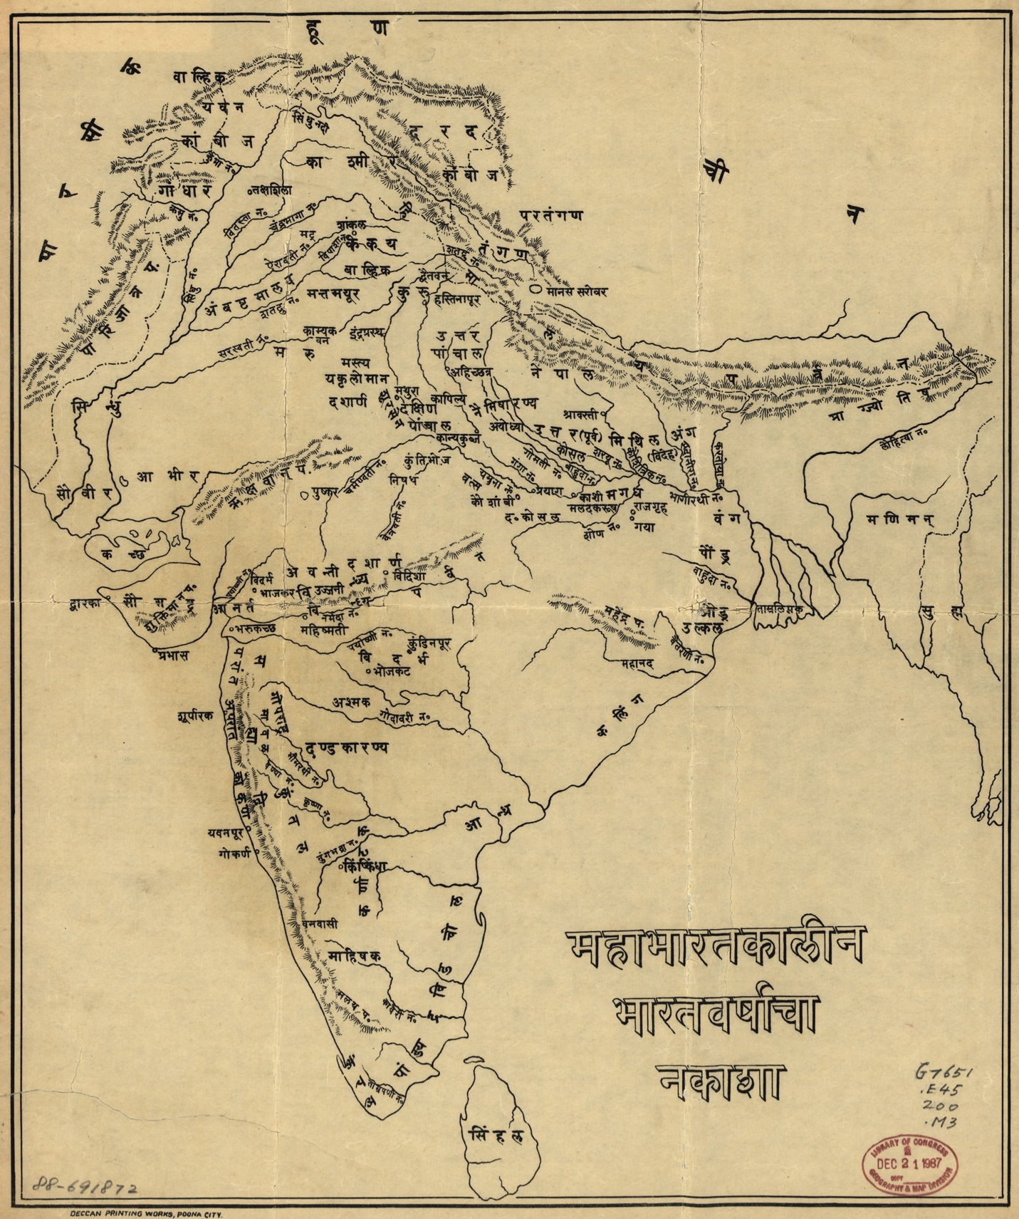
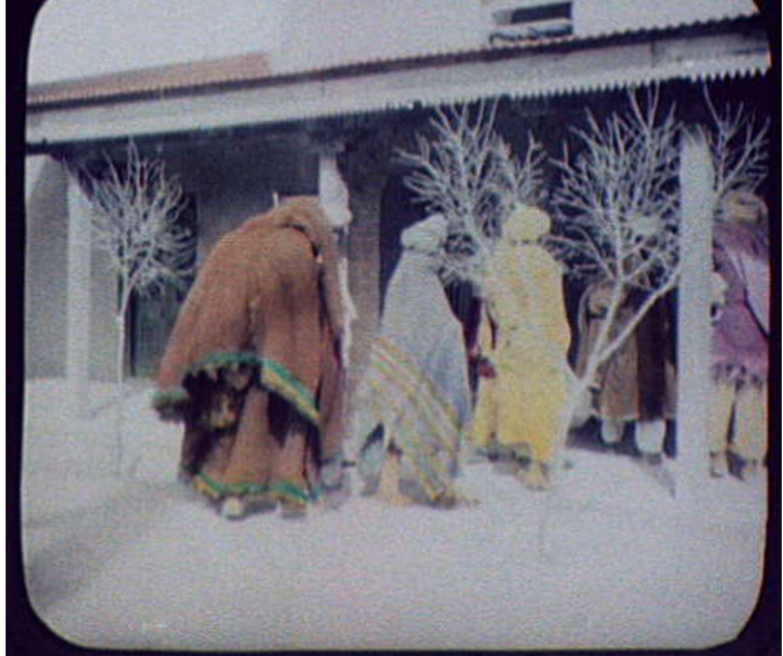
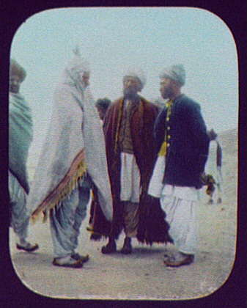

Jackson, William Henry, photographer. 1895. Going to charshit - Indian men entering building. India, Photograph.

Jackson, William Henry, photographer. 1895 The Holy Man of Benares - Swami Bhaskarananda Saraswathi. India Varanasi. Photograph.

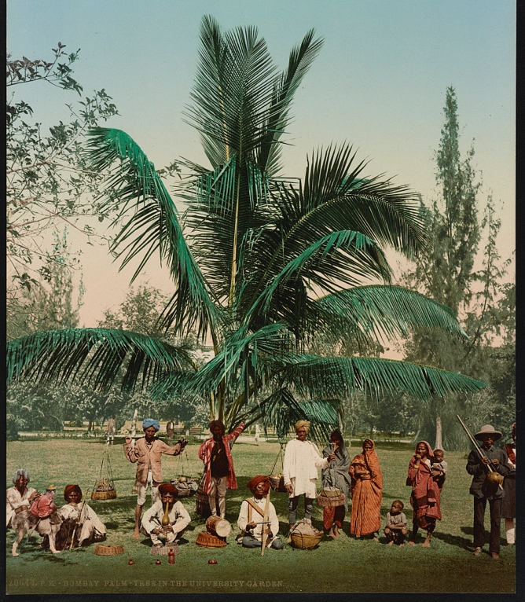
Jackson, William Henry, photographer. 1895. Men in Village Street, India. Photograph.

Photoglob Co, P. (ca. 1890) Bombay. Palm-tree in the university garden. India Mumbai, ca. 1890. [Zürich: Photoglob Company] [Photograph] Library of Congress
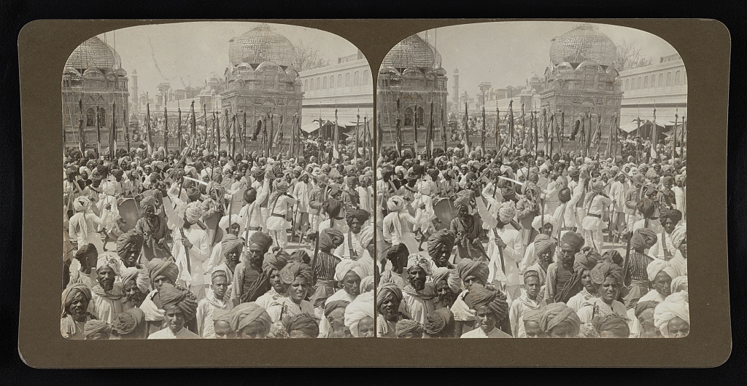
People Gathered in Front of Structure. India. (Between 1860 and 1930) [Photograph] Library of Congress.

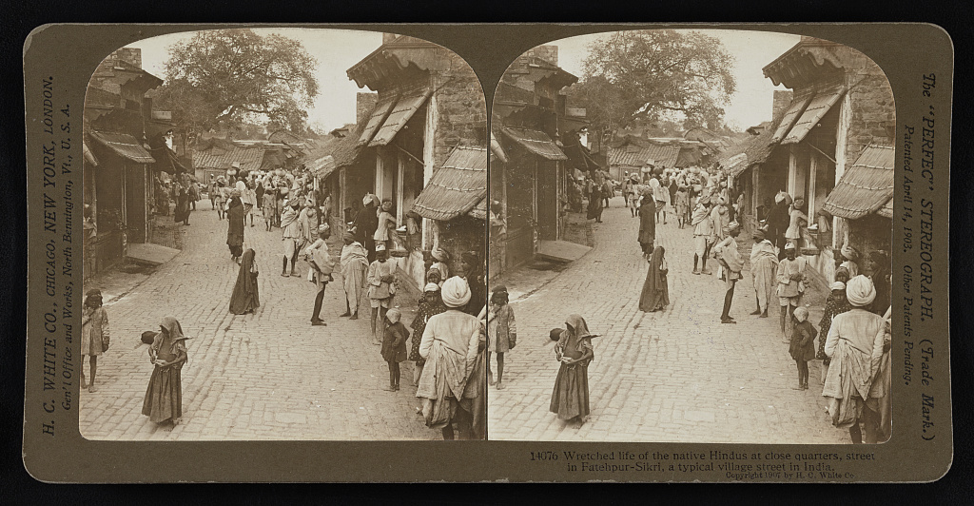
H.C. White Co, P. (1907) Wretched life of the native Hindus at close quarters, street in Fatehpur-Sikri, a typical village street in India. India, 1907. [Photograph] Library of Congress
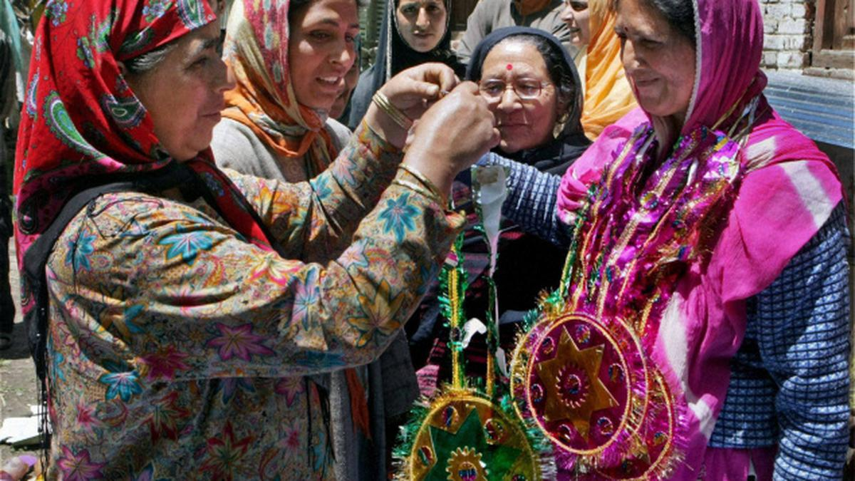
Kashmiri Pandit Asha Jee (R) who won the Panchayat elections from the Wussan block of Kashmir's Baramulla district being garlanded by her Muslim supporters. Photo: Bukhari, Shujaat (2011)

'Samagra Gram Vikas' chapter in Hamirpur district in Uttar Pradesh. Photo: Mehendale, Atharva (2020)

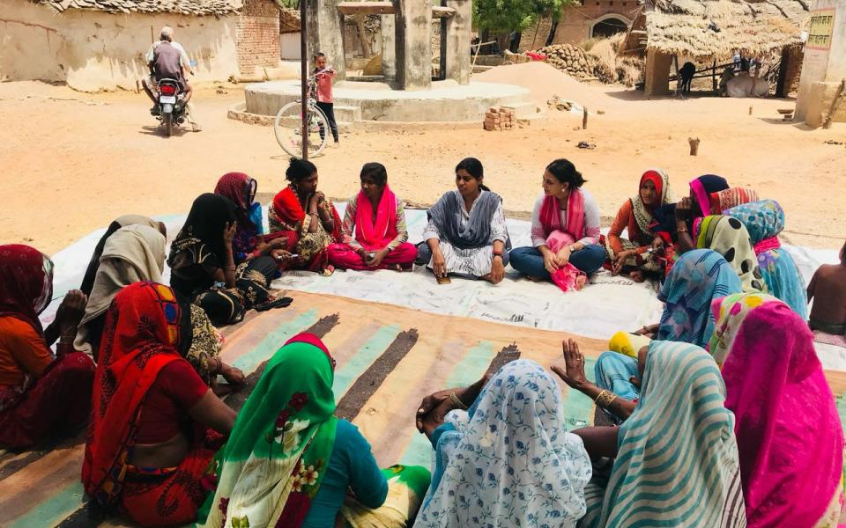
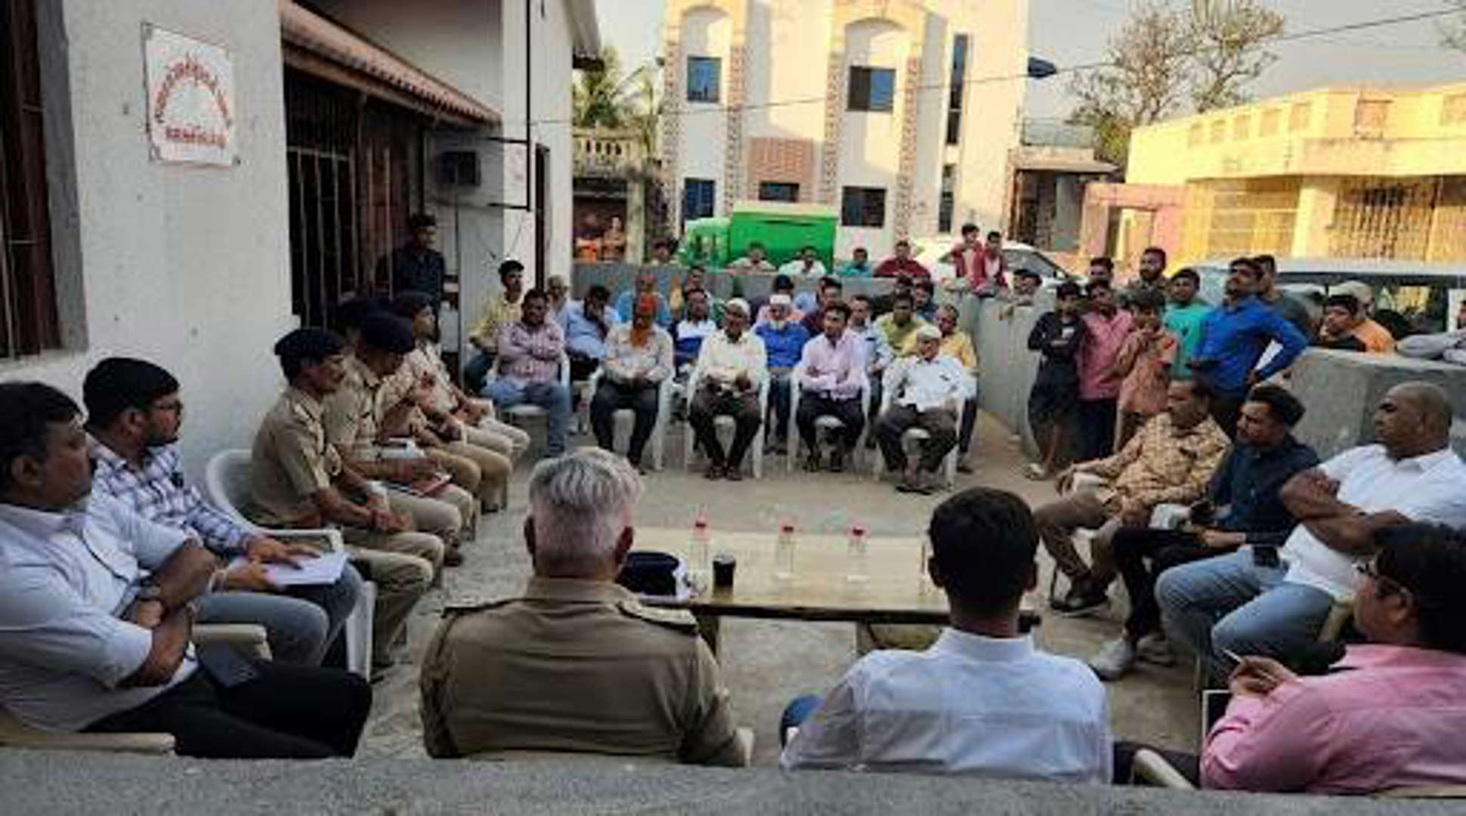

Officials of the district administration and police department held a peace meeting with village elders and community leaders of the Hindu and Muslim communities in Samiala Village, Gujurat. For each youth, a member of the opposite community stood as their surety for bail. Photo: Indian Express, Aditi Raja. March 14, 2023

Gram Sabha meeting in Barkheda village to discuss community issues. Photo: Ishan Agrawal. Aug 4, 2017

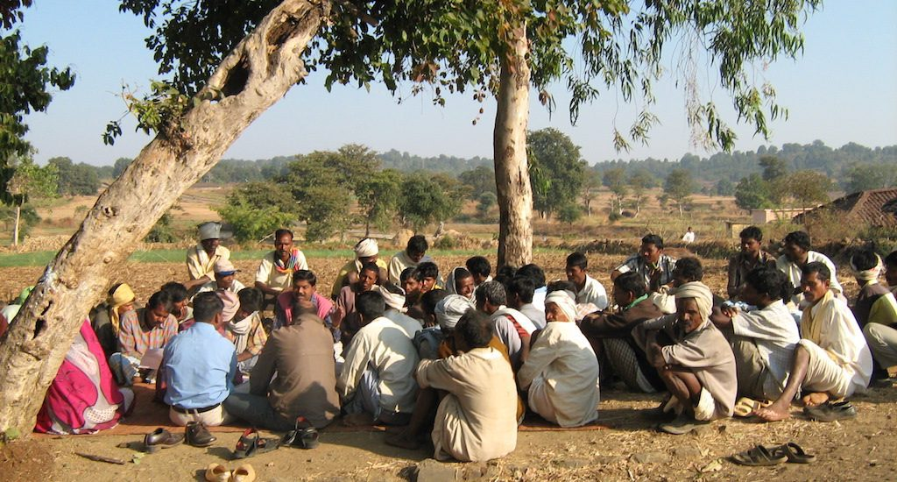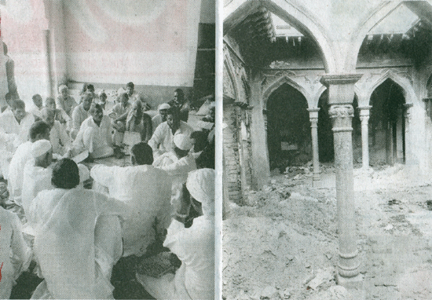 A
A Muzaffarnagar panchayat takes place within masjid destroyed in the 2013 panchayat-led riots.
Akhbare Mashriq Urdu daily, Delhi, 21 Sept 2014. Photo: Muhammad Shahzad

Times of India / Nathowal Village, Punjab/ Dec 27, 2018. Photo: Shariq Majeed

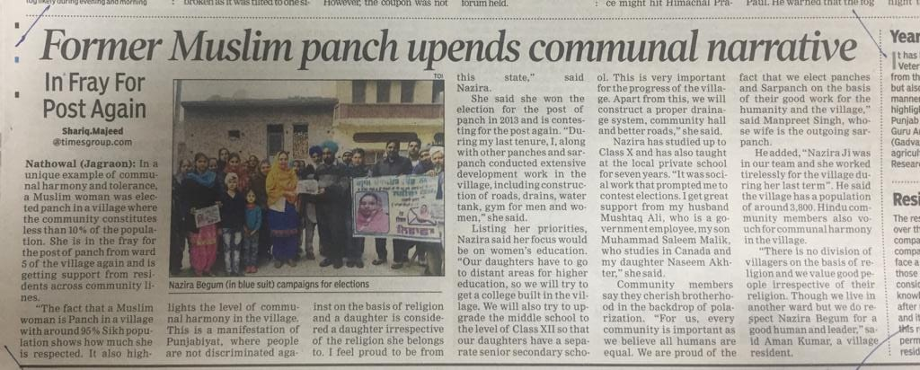

Indian village councils, literally meaning “assembly of five.” Varying hierarchies and some quasilegal variations of village bodies exist across India; among these are Lok Adalat, Gram Sabha, and others with dialect-specific names. Though an oversimplification, for the purposes of this paper, I will refer to such local governance institutions, as Panchayat Raj Institutions (PRIs) or panchayats, as programs of Alternative Dispute Resolution. “Panchayat” is sometimes colloquially used to refer to any village as a unit; similarly, institutions that police caste or religion may be called “khap panchayats.” Neither of these uses are the subject of this paper.
See: Mauro, 1995; Easterly and Levine, 1997; Alesina et al., 2003; Miguel and Gugerty, 2005; Montalvo and Reynal-Querol, 2005; Baldwin and Huber, 2010; Alesina and Zhuravskaya, 2011; Hjort, 2014; Alesina et al., 2016
See also: Baxi, 1976; Galanter and Baxi, 1979; Galanter, 1989
A deeply influential Ismaili Imam
People’s Court
Mogha, Shivam “Calling the Clans” 31 August, 2023. Caravan Magazine. https://caravanmagazine.in/politics/muzaffarnagar-violence-rss-bjp-bku-jat-khap-sanjeev-balyan-tikait
Sharma, Betwa. 2014. “A Village Takes Small Steps toward Reconciliation after Muzaffarnagar Riots.” The New York Times. January 16. https://archive.nytimes.com/india.blogs.nytimes.com/2014/01/16/a-village-takes-small-steps-toward-reconciliation-after-muzaffarnagar-riots/ Raju, S. 2018. “Muzaffarnagar Riots: 4 Years on, Efforts Begin for Compromise.” Hindustan Times. January 1. https://www.hindustantimes.com/lucknow/muzaffarnagar-riots-4-years-on-efforts-begin-for-compromise/story-t8pZ8qLpFwChpBEv8mMr9O.html

